Older Adults’ Perceptions of the Stretch Robot
The College of Applied Health Sciences at the University of Illinois Urbana-Champaign is seeking research participants for an IRB-Approved research study (Approval # 22258).

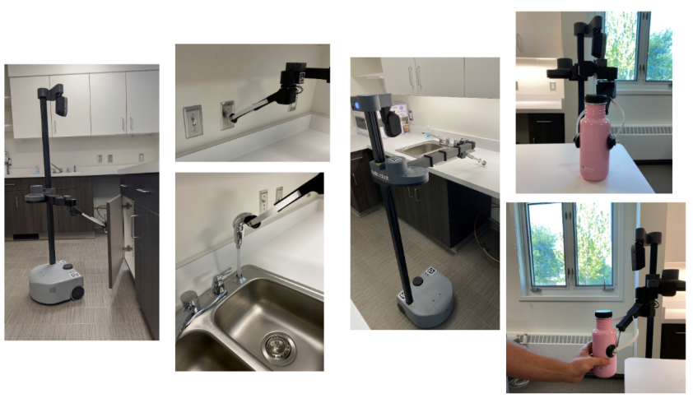

This study aims to learn about older adults’ initial attitudes and perceptions towards the Stretch robot. During this study, older adults will take part in a brief structured interview to discuss their thoughts after watching a series of brief videos of the robot performing tasks in a home setting

Study interviews will last 60-90 minutes for the older adults and take place remotely using Zoom video conferencing.
Participants will receive an Amazon e-code of $25
Eligibility criteria – all potential participants must fit the following:
- Be able to use Zoom video conferencing

- Ages 60-79

- Can read off a computer screen & Size 14 font

Study procedures will take place on Zoom for the protection of our participants during COVID-19.
For more information contact Megan Bayles at mbayles2@illinois.edu

