Robot Opinion Survey
This research study has been approved by the University of Illinois Institutional Review Board – Protocol #20750
The Human Factors and Aging Laboratory, housed within the University of Illinois Urbana-Champaign College of Applied Health Sciences, is seeking research participants for an IRB-approved research study.
SEEKING OLDER ADULTS WHO LIVE IN ILLINOIS FOR AN ONLINE SURVEY
Participants will be asked to review a series of robot videos and answer brief survey questions.
Participation will last approximately 30 minutes
If you participate, you will have a chance to win a $25.00 Amazon Gift Card raffle
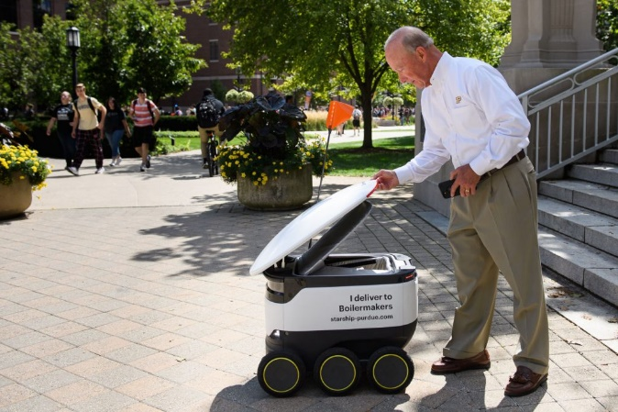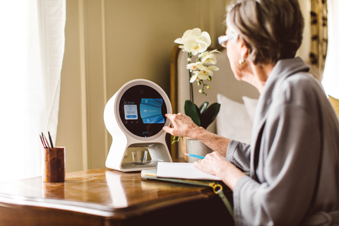
Potential participants who are eligible for this study must be
Age 65-85 years old
Can read off a computer screen and size 14-font
Have computer and internet access
To complete the survey, please visit: https://j.mp/2NyOSfT

For questions, please contact: Dr. Travis Kadylak by email kadylak@illinois.edu or phone (217) 300-5445

