Opening Minds through Art
Art Show
Presented by Circle of Friends Adult Day Center
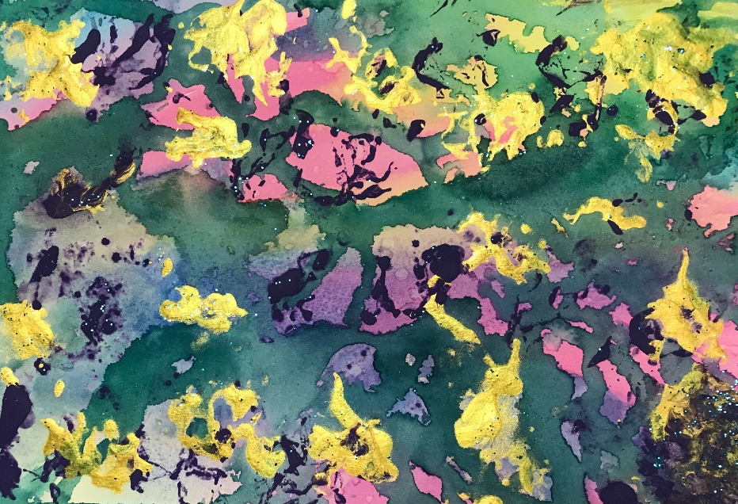

Opening Minds through Art (OMA) is an intergenerational art program for people with dementia that is aimed at promoting their social engagement, autonomy, and dignity through the experience of creative self-expression.
Please join us at the Center for our show honoring our artists
and their University of Illinois student volunteers
Thursday May 3, 2018, 3:30-5:30 p.m.
Circle of Friends Adult Day Center,
609 W Washington St, Champaign, IL
For questions call Kathy Rhoads or Robin Cain (217) 359-7937
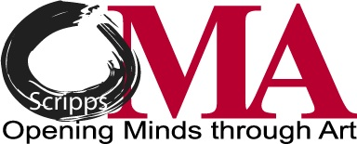
Funding provided by SIU School of Medicine

