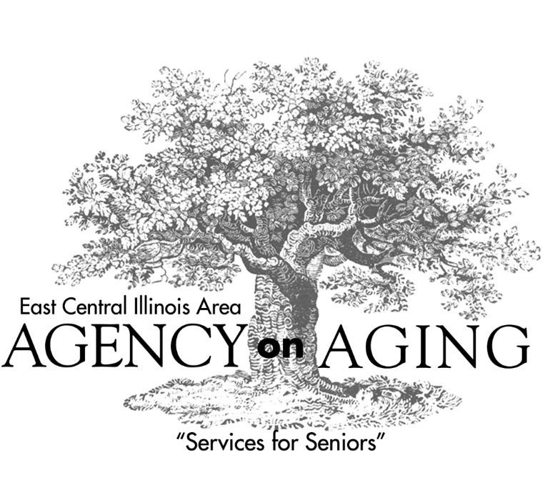
ECIAAA
wants
to hear from you!

Have you, or someone you know…
Received a home delivered meal?
Received help with a Medicare Part D application?
Attended a support group for family caregivers?
Obtained legal assistance to deal with a public housing issue?
Community-based programs serve as a lifeline for older adults, caregivers, grandparents raising grandchildren and individuals with disabilities. State and federal funding for these services must be preserved and increased.
Your voice is vital and must be heard! Please join us for the Champaign County Conversation on Aging.
When: 2:00 p.m. – 4:00 p.m.
Thursday, February 1, 2018

Where: Champaign Public Library
200 W. Green Street, Champaign, IL

Please bring a friend! For questions, please contact Susan C. Real,
ECIAAA Executive Director at 309-829-2065 or by email at sreal@eciaaa.org.

