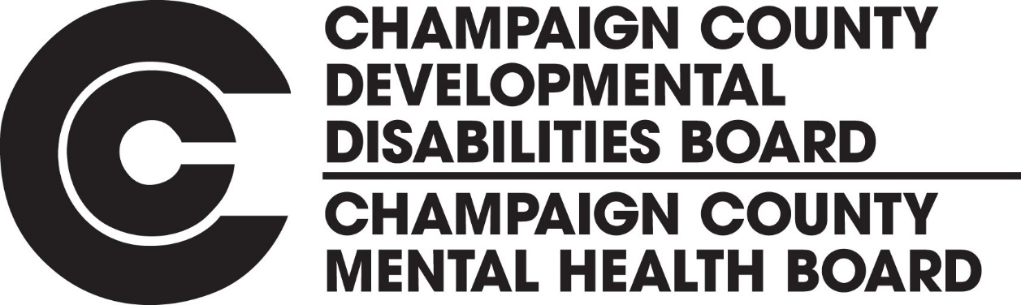

Community Needs Assessment Survey
The Champaign County Mental Health Board and the Champaign County Developmental Disabilities Board are interested in hearing your opinion about mental health, substance use disorder, and intellectual and developmental disability services in Champaign County. How have you or a family member been helped? Or did you or a family member have a need that could not be met? We want to hear from you!
As a person with a mental health condition, substance use disorder, or intellectual or developmental disability your experience with the local system of services is something we would like to hear about from you. As a family member, guardian, or friend of someone with a mental health condition, substance use disorder, or intellectual or developmental disability, your knowledge and experience with local services is also of interest to us as are the opinions of providers, stakeholders, and other interested parties with knowledge and experience with local behavioral health or intellectual and developmental disabilities services.
To better understand how the services and supports available in Champaign County are used, what is going well, and what should be improved, we invite you to complete a survey about your experiences. All responses are anonymous. No names or addresses are required to see or complete the survey.

Surveys are available now through January 31, 2018.
___________________________________________________________
To complete a survey, go to: www.champaigncountysurvey.com
______________________________________________________________________
If you prefer to complete a paper copy or need other assistance with the survey, please contact the CCMHB/DDB at 217-367-5703 or send an e-mail to survey@ccmhb.org
Your opinion matters! Let your voice be heard!

