East Central Illinois Area Agency on Aging
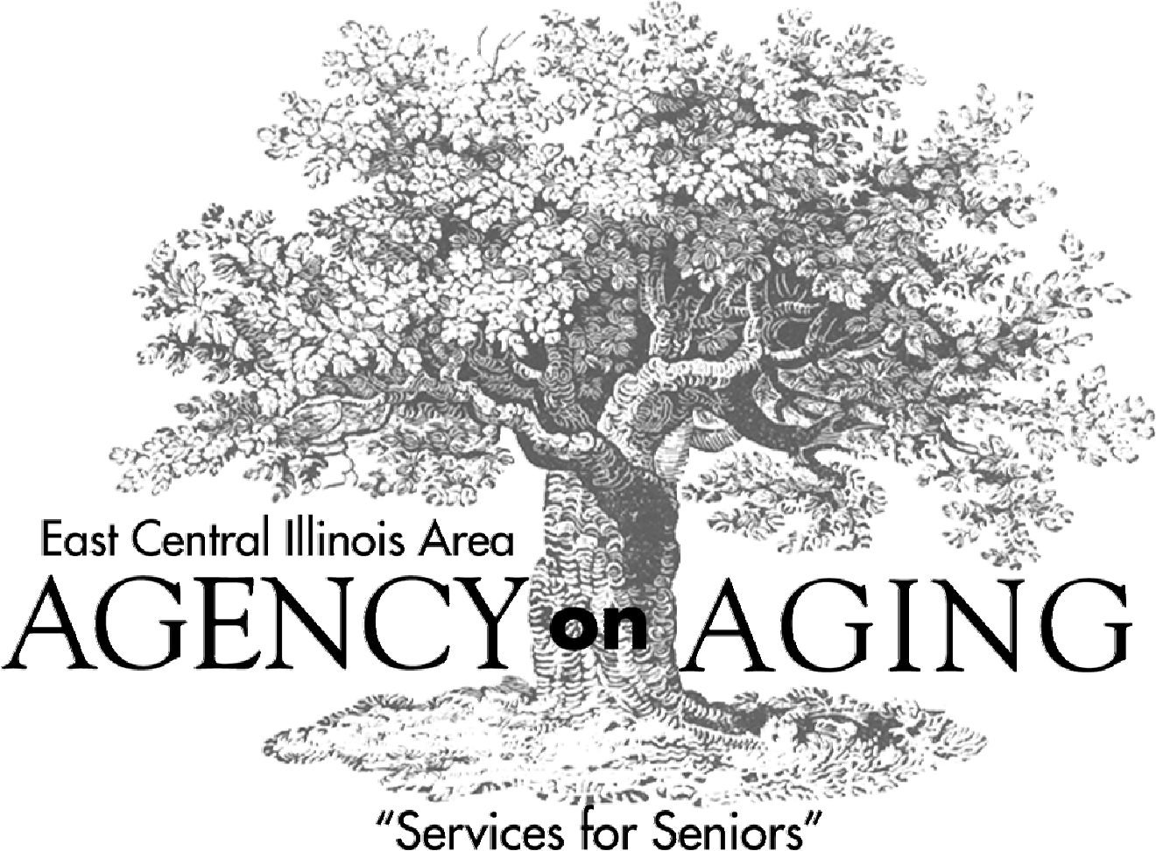
PUBLIC HEARINGS
On the
AREA PLAN FOR FISCAL YEARS 2017-2018
Public Hearing Schedule
Date | Time | Location
April 29 | 10:00-11:30 a.m. | Decatur Macon County Senior Center, 1430 North 22nd Street, Decatur, IL
April 29 | 2:00 – 3:30 p.m. | East Central Illinois Area Agency on Aging, 1003 Maple Hill Rd., Bloomington, IL
May 2 | 10:00-11:30 a.m. | LifeSpan Center, 11021 East County Road 800 North, Charleston, IL
May 2 | 2:00-3:30 p.m. | Family Service, 405 South State Street, Champaign, IL
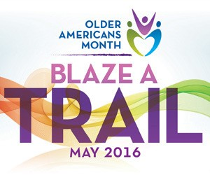

NOTICE

The East Central Illinois Area Agency on Aging publishes this Public Information Document as the official summary of the proposed Area Plan for Fiscal Years 2017-2018. A summary of this document will be presented at Public Hearings (see schedule below).

A summary of public comments will be presented to the ECIAAA Advisory Council on May 4, 2016 and to the ECIAAA Corporate Board on May 18, 2016 for their consideration.

Comments on the proposed Area Plan for Fiscal Year 2017 may be sent by mail, fax or e-mail to ECIAAA no later than 4:00 p.m., May 3, 2016 to the following address:

Attention: Susan C. Real, Executive Director East Central Illinois Area Agency on Aging
1003 Maple Hill Road – Bloomington, IL 61705-9327 Fax: (309) 829-6021; E-Mail: sreal@eciaaa.org

The East Central Illinois Area Agency on Aging will conduct a series of Public Hearings to inform older adults, persons with disabilities, family caregivers, grandparents and other relatives raising children, and other interested individuals and organizations about the proposed Area Plan for the remaining years (FY 2017 & FY 2018) of ECIAAA’s current three-year Area Plan (FY 2016-2018).

Date | Time | Location
April 29 | 10:00-11:30 a.m. | Decatur Macon County Senior Center, 1430 North 22nd Street, Decatur, IL
April 29 | 2:00 – 3:30 p.m. | East Central Illinois Area Agency on Aging, 1003 Maple Hill Rd., Bloomington, IL
May 2 | 10:00-11:30 a.m. | LifeSpan Center, 11021 East County Road 800 North, Charleston, IL
May 2 | 2:00-3:30 p.m. | Family Service, 405 South State Street, Champaign, IL

The Public Hearings will present information about national, state and local initiatives, including:
- Reauthorization of the Older Americans Act for FY 2015
- Proposed Older Americans Act funding for FY 2017 for services in Planning and Service Area 05, as allocated by Illinois Department on Aging (IDOA)
- Proposed Illinois Community Reinvestment Program as presented by the Illinois Department on Aging (IDOA)
- The funding crisis ECIAAA-Service Providers are experiencing based on the current Illinois Budget Impasse for FY 2016
Under the Older Americans Act and the Illinois Department on Aging’s direction, ECIAAA is required to present its plan for the allocation of Older Americans Act and Illinois General Funds for services as contained in its AAA Planning Allocation Directive for FY 2017. The Public Hearings provide information about ECIAAA’s proposed plans, budget, funding formula, and priorities for funding community-based services for older adults and family caregivers, including: Coordinated Points of Entry/Senior Information Services, Legal Assistance, Congregate Meals, Home Delivered Meals, Evidence-Based Health Promotion Programs, Gerontological Counseling, Caregiver Advisory Services, Respite Care, the Adult Protective Services Program, and the Ombudsman Program.

For more information contact Susan Real, ECIAAA Executive Director by email at: sreal@eciaaa.org.

