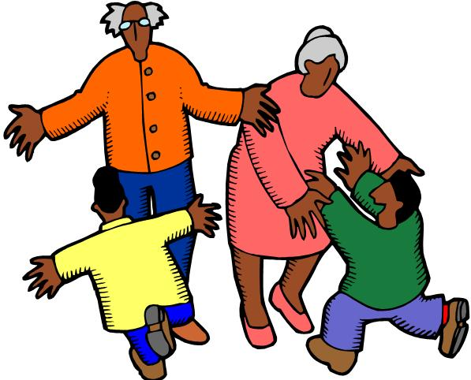


National Grandparents Day is
September 13
Celebrate with your favorite kids!

Grandparents enjoy a wonderful afternoon
for you and your grandchildren here at the Champaign Public Library.

Sunday, September 13
Robeson Room AB from 3-4

Work together on a take-home craft.
Sing along to fun music.
Share a snack and a smile.
Make some memories.

Free and open to everyone!

No registration required.
All ages encouraged to attend.
For more information call 403-2070
Champaign Public Library
200 W. Green St. Champaign, IL

