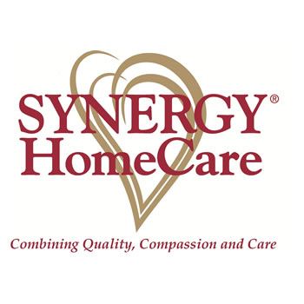
Please join us for a Celebration of our Grand Opening/ Ribbon Cutting!!!

Synergy HomeCare of Champaign
2213 S. Neil Street
Champaign, Illinois 61820
217-318-0268
Thursday, April 30th
4:00-7:00 p.m.

We are so excited to be a part of the Champaign Community- Please help us celebrate…Appetizers, Cocktails and Fun!!!

